Elwha River former Lake Aldwell Reservoir
OK. This lab was created by Bryon Free – it’s a significant chunk of his MS thesis. As you may know, a few years ago, a couple of dams were removed from the Elwah River.

If you don’t know much about this, spend a few minutes on https://www.nps.gov/olym/learn/nature/elwha-ecosystem-restoration.htm and Google. Spend a little time getting familiar with the area and what’s happened. It’s pretty cool. And local. Reasonably.

Bryon’s thesis was looking at how the sediment moved downstream post-dam removal. He used mostly terrestrial LiDAR. Think of the below piece of instrumentation set up by the river, then scanning in all directions.
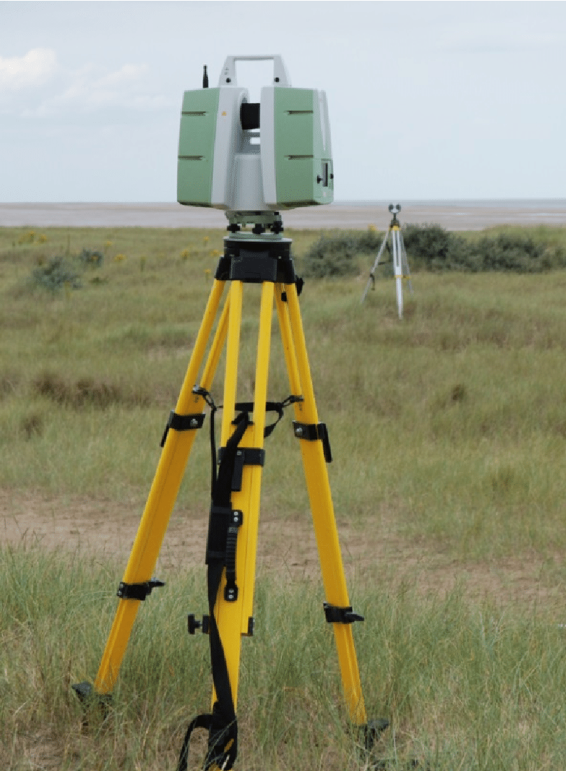

You’re going to make DEMs from the two years of data – and then, using raster calculator, subtract one from the other. This will give you a handle on how much sediment was removed, and where, from the system. The 2012 data was pre dam removal; the 2014 was post. Thus, you will be looking at the changes caused by slug of sediment being washed downstream. All data is in meters.

When doing this lab, make sure you’re working with someone who is ArcGIS proficient! Yes, feel free to work in pairs.

- Download the LiDAR data from the data drive to your flash drive and unzip it. There are two years of data within. Note, these are LARGE files. Make sure you have lots of space on your flash drive (9 gb for just the unzipped files). Delete the zip file when done, just to save space. If necessary, you can always grab it later.
- Open ArcGIS Pro. Make sure you create a new project on your flash drive, not elsewhere. This will be important.
- Now create a LAS Data set: follow this process for both the 2012 and 2014 data
(This will combine all of the LiDAR data points into the ARC window so that you can view them as individual points. This is the only way for ARC to combine the metadata needed to filter the point returns.)
  - Goto Analysis – tools and then search for “Create LAS Dataset”
    - Input: The LAS data files (all of them by year, one at a time. One year at a time) that you collected from the drive. So you will end up with two files, one for each year.
    - Output: Create a file name and location for the dataset
    - At the bottom of the dialog Select “Compute Statistics”
      - This will filter all of the unneeded LAS data that comes written into its header and only displays what data actually exists
    - Keep all other presets including environments. Run it.
    - open the .lasd file in arc.
  - At this point you should see red boxes bounding the extents of each of the LAS files you combined into a dataset (at the zoomed out extent it is too much data to display all at once so you will not see LiDAR points yet). You should have one set of boxes for each year at this point.
    - This is a good time to question your data. Look in the Table of Contents you should have a classified set of elevation values.
      - Do the elevation values make sense?
      - Check with google earth to see if the lows and highs work right (As in, are they close?) Remember, you can change GE settings in tools-options.
    - When both LAS datasets are created, right click on the file name in the TOC and goto LAS filters and select “ground”. [Do this for both files] (This is going to filter all but the ground return data points in the LiDAR file and determine what data points are processed in the next steps below.)
  - Now choose one dataset to look at and turn the other off (We only want to look at one dataset to answer this question. Either one will work). Change your basemap to world imagery.
    - Find a point where you can see forest vegetation and riverbank and Zoom in to 1:500 (at this ratio the points will become visible on the screen)
    - Notice the density of points between the river and the vegetation. Those over the river are denser than those over the vegetation. Why so you think this is happening? Think about how the scanner works and how it is placed.

- Now we need to create a bounding polygon around just the data that we want to difference.
  - Goto view – catalog pane – databases – then right click on your geodatabase (that you created when you started Pro). Select new – feature class. Give it a useful name. Make sure it’s a polygon. Keep the Z values checked. Use the add data button to add this to your contents view.
  - Now create a polygon by going to edit – create, then selecting your polygon layer name, and then clicking on the polygon tool. draw your polygon loosely surrounding the river and its’ floodplain (be sure not to include any of the forest at the edges of the floodplain) - within the LAS Dataset boxes. (This is creating a file that will bind your processing extent and create a mask for the data in all future processing). Hit the edit – save button to save this polygon.
- Creating DEM’s from a LAS Dataset (Do this for both LAS Datasets) We will be building 1-meter DEM’s
  - Now, goto analysis – tools, and search for “las to raster”. Select the LAS Dataset to Raster tool.
    - Input: Choose your LAS Dataset
    - Output: put this in the file geodatabase that you created earlier and name the data with “DEM” in the naming scheme.
    - For interpolation:
      - Triangulation
      - Linear
      - No Thinning
      - Data type should be floating point.
    - Sampling type should be set to “Cell Size” and Sampling value should be set at “1” (This will determine a 1-meter cell size)
    - Environments
      - Set the extent to the feature class/polygon that you created earlier.
      - Run it. Might take awhile, be patient.
    - [IMPORTANT] When creating the second DEM in the Environments Tab
      - Under the processing extent make sure to “snap” this new DEM to the first DEM you created. (This will align all of the cells on top of one another for a true comparison of data). Use all other settings as above.

Before we difference the DEM’s we need to cut them down to just the data we need.

- In the search dialog (analysis – tools) enter “Extract by Mask” and select it. (You will do this for both DEM’s)
  - Input Raster: enter your DEM data
  - Input Feature data: use your Feature class polygon mask that you created
  - Output: New smaller DEM
  - [IMPORTANT] When creating the second DEM in the Environments Tab
    - Under the processing extent make sure to “snap” this new DEM to the Raster you just created. (This will align all of the cells on top of one another for a true comparison of data)
- Create a “Hillshade” for each of your DEM’s using the feature class/polygon as a raster analysis mask and snapping to the original raster.

Note, for something cool, spend some time zoomed in on the hillshade (so you can see the little channels). Now, turn the DEM on and off with the basemap imagery visible (toggle between the two) – you can see that the dates of the LiDAR and the imagery are different, as the channels are different. Which you would expect.
Now let’s create a DEM of Difference (DoD)

- Find the Raster Calculator tool using the search function.
  - In this field we will subtract the 2014 DEM from the 2012 DEM (2012-2014). (This will subtract the cell values (elevation) on a cell by cell fashion and output a DoD). Note, there should be more sediment in 2012 – making this the higher elevation of the two DEMs. Thus, anywhere there was erosion, the values should be positive; if there was deposition, the values will be negative.
- Now overlay the DoD on the 2014 DEM hill shade and adjust the transparency to 40%. In the properties window chose a classified symbology – in cases like this, 0 should always be a class break. For the color scheme choose the Blue to Red with Blue identifying an increase in elevation (erosion) and red a decrease in elevation (deposition). Note. You should also make a map in which everything from +.02 to -.02 m is colored the same. These would be areas where change was pretty minimal – and you can probably write this off to errors in the system (plus or minus 2 cm)
- Observe the DoD its Blue (Elevation increased) over most of the DEM why is this? Is this real change?

- We know that the road didn’t move use the identify tool to look at the elevation of both DEM’s that were compared. What is the difference in elevation between them?

- How can we fix the elevation difference so that we have less error in the DoD?

- What are other possible areas of “Bad data” when differencing the DEM’s?

- Deliverables
  - All three maps, pasted into a word document. (1 Map per Page): the two final hillshades and the DoD. The DoD must be in color.
  - Typed sentence form answers to the questions asked (italicized and red)
  - Work in pairs, only hand in one writeup with both your names on it.

