Geog 301 lab: Tissot’s indicatrix
Lab written by Sterling Quinn
In this lab you’ll explore the effects of different map projections using a tool called Tissot’s indicatrix. This is just a lattice of elliptical features of equal dimensions on the globe. When the map is flattened into a projection, the ellipses change shape and size, helping you to see where the projection introduces the most distortion.
Preparatory reading
Before beginning, carefully read the short post on the Esri ArcGIS blog titled Tissot’s indicatrix helps illustrate map projection distortion. This was written by one of Esri’s most experienced research cartographers, Aileen Buckley, and she was nice enough to share the data in the blog post for everyone to use.
Instructions
You’ll be using Esri’s ArcGIS Pro for this and many other lab exercises. This is part of Esri’s ArcGIS Desktop suite, which is probably the most widely-used desktop-based mapping software. It’s going to look a lot more complex than ArcGIS Online when you open it, but don’t let that scare you. The only way to learn ArcGIS Pro is to use it, one feature at a time.
- On a lab computer, navigate to the path j:\301_w_22\ and copy the entire “Tissot” folder to your own drive.
- From your own drive, open this folder, navigate into the ../tissot/Tissot/ folder, and double-click the file Tissot.aprx
An .aprx is an ArcGIS Pro project file, so when you double-click it, ArcGIS Pro will open up. You’ll see a map very similar to the one in the above blog post, containing the tissot ellipses, the graticule (grid of latitude and longitude lines), and outlines of world countries.
You can display and hide the different map layers by checking the boxes on and off in the left hand Contents window; however, that is not necessary right now.
- In the Contents window, right-click Layer and click Properties.
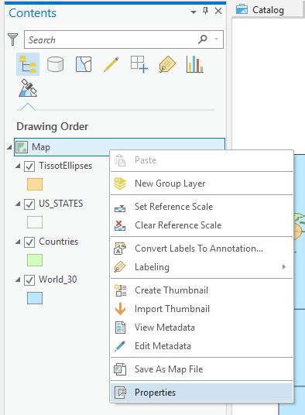 (in pro 3.x, instead of map, it says layer)
- Click the Coordinate Systems menu item. This is where you can choose which projection you want to use in your map. Right now you will see GCS WGS 1984 highlighted in the list, but this is not actually a projection.
- Beneath the area that says XY Coordinate Systems Available, scroll down to the Projected Coordinate System folder and expand it. You’ll see a lot more folders inside with different kinds of projections to choose from. Dig through this tree of folders for a bit and look at some of the different ones.
Let’s practice reprojecting this map a few times. For our first one, let’s choose the projection used by Google Maps.
- Still working in the Coordinate Systems menu item, expand the folder Projected Coordinate Systems > World and select WGS 1984 Web Mercator (auxiliary sphere). Then click OK. Your map should morph the country shapes into something that looks like Google Maps, although you’ll probably realize right away that Google cuts off their map at extreme latitudes (because this one in ArcGIS isn’t cut off).
Notice that the ellipses in the indicatrix are all the same shape, meaning that this “Web Mercator” projection is a conformal one. However, the sizes of the ellipses are grossly distorted as you get closer to the poles.
This projection actually works pretty well if you stay close to the Equator. Suppose you turned it on its side and only used it to map a small vertical slice of the earth? Well, this is actually the purpose of the Universal Transverse Mercator (UTM) projections, which cover the earth in 6-degree-wide vertical slices. Let’s try Zone 10 North, which is the one our university sits within.
- Use the same procedure as above to display the list of coordinate systems, but this time choose Projected Coordinate Systems > UTM > WGS 1984 > Northern Hemisphere > WGS 1984 UTM Zone 10N.
Notice how the west coast of the USA is smack dab in the middle of this projection, and that the ellipses stay relatively similar in size as long as you don’t go too far east or west of this. In fact, ArcGIS Pro does not show the entire world here because the remainder of it would be too distorted to be useful. If you want to map the world, you should use a different projection.
The UTM zones are some of the most common projections used for mapping the US. Another common approach is to use the State Plane system. Similar to UTM, the state plane projections are tailored to relatively small zones, and are used for local mapping only.
- Fire up Google and search for a map of State Plane Zones. Notice how some states are divided north-south and others are divided east-west. Keep this map open for the next few steps.
Let’s start by reprojecting into the state plane zone where our university sits.
- Using the techniques learned above, reproject your map into NAD 1983 StatePlane Washington South FIPS 4602 (Meters). If you can’t figure out which folder this is in, use the search box at the top of the Coordinate Systems tab.
Notice that if you printed this map and cut it out, you could create a cone shape. Because the State Plane Washington South zone is horizontally oriented, it uses a conic projection. The areas near where the cone intersects the earth have the least amount of distortion. If you click the Details link in the Coordinate Systems menu, you will see that the cone intersects the earth at the latitudes 45.83 degrees north and 47.33 degrees north running through the southern part of the state of Washington.
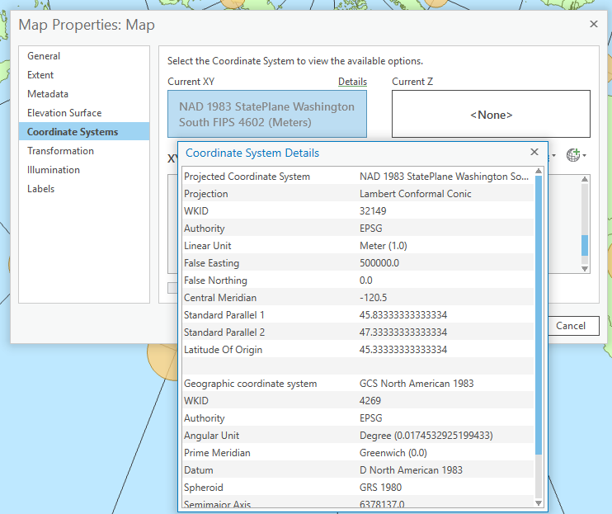
- Reproject your map into NAD 1983 StatePlane Arizona East FIPS 0201 (Meters).
When a state plane zone is vertically oriented, like Arizona East, then a transverse mercator projection is used instead of a conic one. This is a similar technique to UTM, but the central meridian of the projection is customized to go through eastern Arizona.
Now let’s look at some common projections for world and continental mapping.
- Reproject your map into North Pole Azimuthal Equidistant. Notice that although the tissot ellipses get elongated, their semi-minor axis is always the same length. All distances measured outward from the north pole to the south pole are preserved correctly.
- Reproject your map into Europe Albers Equal Area Conic and zoom in to Europe using the mouse wheel. (I’ve noticed this map has a tendency to go nuts when zoomed way out in this projection). Because it’s an equal area projection, all the circles have the same area, even though their shapes are distorted.
This is great for a general map of Europe, but what if we were making a map centered on the United Kingdom? Right now that region is slanted a bit, but we could put it in the middle of the projection by tweaking the central meridian.
Open the Coordinate Systems tab of the Map properties again, as if you were going to change the projection. This time, right-click Europe Albers Equal Area Conic and click Copy and Modify. This allows you to type in your own parameters. The central meridian is set currently at 10 degrees longitude. Change this to 0 and rename the projection to Europe Albers Equal Area Conic Customized as shown below. Then click Save and OK.
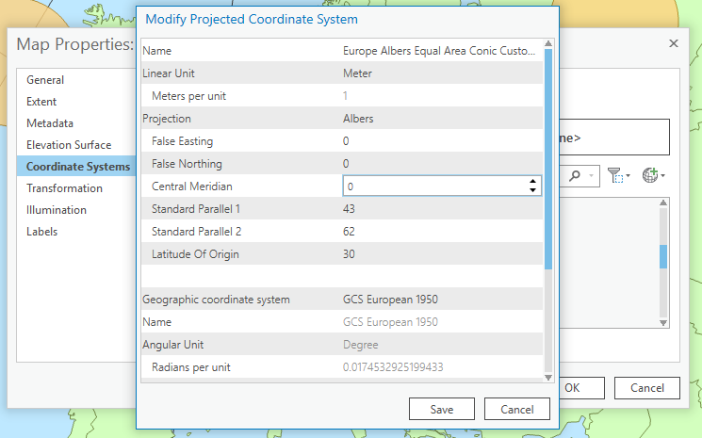
The projection should now be oriented with the United Kingdom in the center. If we wanted to further center this projection on our area of interest, we could change the standard parallels so that they cut through the UK. You can try this if you like, although it is not required.
Tissot’s indicatrix lab deliverables
Now it’s time to think about what you just did. On this page or a blank one, type out answers to the following questions. Don’t waste paper by turning in all the stuff above this page.
- Suppose I am making a map of the continent of South America. Explain why a UTM projection would not be appropriate for this map and what problems could be introduced by using a UTM projection.
- UTM zones are six degrees wide and begin at -180 longitude. They start with Zone 1 and increase in number as you move eastward. Zones are also cut into “North” and “South” based on whether they are north or south of the Equator, respectively. You can Google a phrase like “UTM Zone Map” and look at images of the zones online.
Given this information, which UTM zone would be most appropriate for a map of Provo, Utah (lat/lon coordinates 40.24, -111.66)? Explain in general terms (you don’t have to write a formula unless you want to) the mathematical approach that could be used to arrive at the correct UTM zone.
- Project the Tissot Indicatrix map we used in this lesson into the State Plane zone for Tennessee. Is this zone based on a conic projection, or a transverse mercator projection? How can you tell?
- You want to make a map of the Pacific Northwest. The UTM and State Plane zones are too small for this, so you decide to use the North America Lambert Conformal Conic projection. This looks great, but the only problem is that when you apply this projection in ArcGIS Pro, the Pacific Northwest is oriented somewhat diagonally. Explain in general terms how you could fix this problem. Then give the technical steps required to do it in ArcGIS Pro.
- Using the Tissots Indicatrix map that we used in this exercise, apply the solution you came up with for question 4 above and insert a screen capture of the resulting map below.

