Pre-lab stuff! Making sure you have an esri account, etc.

First, I want all of us to log into my.esri.com. This is where you will manage your ESRI life. Log in with the username and password given to you in class. Start by changing your password to something you will use. It's under "my profile". Get this changed, then logout.

You will need it for this lab and for all future labs. So, remember your esri username and password.

Also, remember to logout of your account each time you use it!

Now, onto this week’s lab.

Geog 301 lab: Exploring the world using digital maps

This lab was originally developed by Joseph Kerski at Esri, Inc. and Anthony Robinson at Penn State University as part of an online course on maps. It was adapted for use in GEOG 301 by Sterling Quinn. And then further modified for Geog 301 by Bob Hickey.

Introduction
You probably already use cloud-based technologies when you use Google Drive, Facebook, Flickr, or Dropbox, for example. Web mapping is geographic information systems (GIS) in the cloud. Web mapping includes spatial data in the form of maps, databases, map services, and satellite images, and it also contains tools and functions such as the ability to measure things and to do spatial analysis.
Not all digital maps are dynamic; millions of maps exist in presentations, PDFs, and as static images like the ones you'll see in our class lectures. But unlike static digital maps, dynamic digital maps can show real-time things like weather, floods, or traffic. Layers of information can be added or subtracted from them so that you can change the map design yourself at will. The scale, colors, symbols, and the way their data is classified can all be changed. They can be embedded into live web pages, changed from 2D to 3D, and formatted for a smartphone. Therefore, they move beyond being simply reference documents (“Where is Uzbekistan? OK, great! Next?”) to being tools of geographic inquiry, used to understand spatial and temporal patterns in order to solve problems.
To give you hands-on experience making your own maps and doing spatial analysis, we’ll be using Esri’s (www.esri.com) cloud-based GIS called ArcGIS Online. Joseph Kerski works for Esri’s Education Team and has done a ton of great work to help incorporate ArcGIS Online into this lab content. ArcGIS Online does many of the things a desktop GIS system can do, but it has a much easier learning curve, can be used right in your web browser, and makes it really easy to share interactive maps you make with others.
Investigating Global Population and Ecoregions
Have you heard about “big data?" Since they seek to understand the whole world and everything in it, geographers were into big data way before the term existed. With the explosion of datasets of all types, geospatial data abounds as well, at scales from local to global, and across themes ranging from natural hazards, to energy, to water, and geology. For example, in terms of population, not only can you obtain the locations of cities, but the size of those cities, and not only total population counts, but also population density, how population is changing, and characteristics of the population such as age, ethnicity, income, education, life expectancy, and other variables. You can examine the relationship of population to other phenomena, represented as map layers. In this lab, you will examine the relationship of where people have settled to the physical environment. You will also determine how population impacts the physical environment in which it exists.
Before you start using the tools, try to answer the following questions as best you can. You won't be submitting these particular answers, but you may want to write them down someplace.
- What is an ecoregion? You’ll probably want to fire up your Google to sort this out. That’s what I’d do.
- In what ecoregion do you live?
- What is one factor that influences population density in a given area?
- Describe the population density in the neighborhood in which you work. Make a little note of what you think this is. You’ll need it later in this lab.

Let’s Make a Map
When you’re ready to begin, click here. You may want to adjust your windows so that you can see both the lab instructions and the mapping tools at the same time. Use Chrome or Firefox. IE/Edge is for noobs and is the least compatible with ArcGIS Online.
This map was built using ArcGIS Online. First, note that you have the map occupying most of the screen (as it should be!). Second, you have a set of map layers on the left. Third, you have tools—some of which are at the top, and some are available through the list of layers on the left.
This map shows Ecoregions, Population Density, and Imagery. To see these, select “Modify Map” in the upper right of the interface, then click Content above the Legend to see the list of available layers.
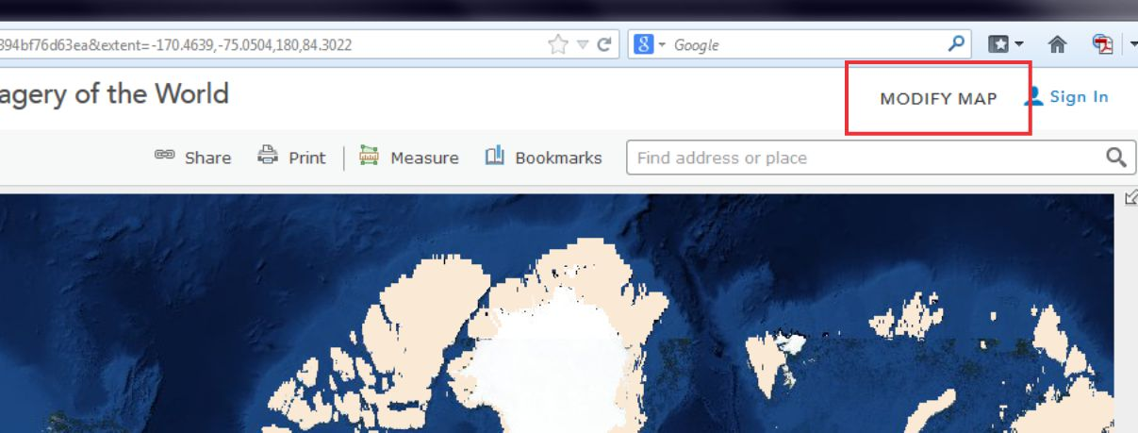
Take some time now to explore the About, Content, and Legend buttons directly above the Legend. Get comfortable with what these buttons do. Zoom using the vertical scale bar at the left side of the map—the middle scroll wheel of your mouse if you have one—or by holding the shift key and drawing a box on the map with your mouse. Bookmarks are another way to zoom in or out (change the map scale).
Now use Bookmarks (just left of the search bar at the top) and select World. Show the map legend. Your map will look something like this, although the styling may vary a bit:
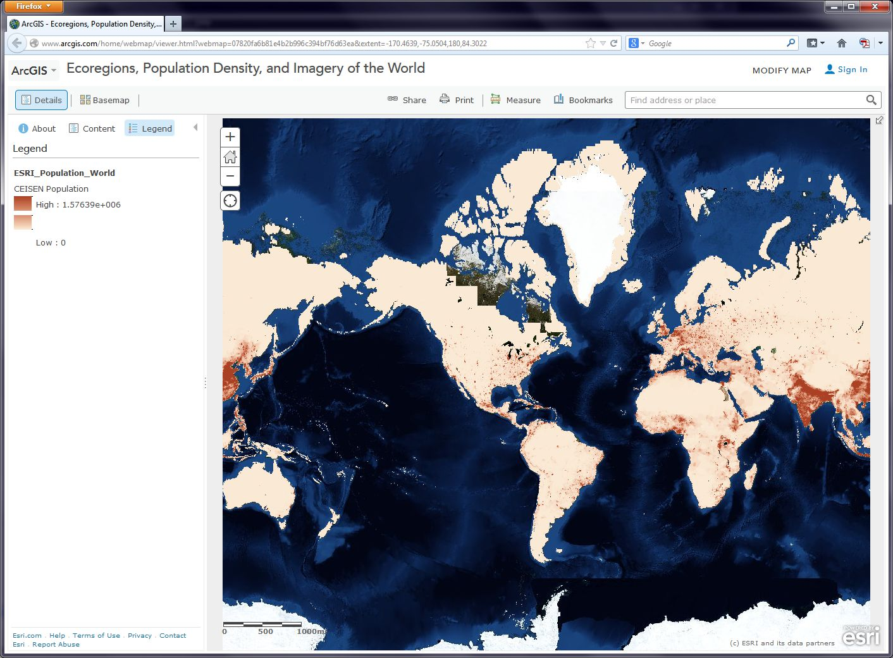
- Think about how you would describe the pattern of world population density
Click the Basemap button and change the Basemap back and forth from Imagery to Terrain With Labels so that you can refer to country and city names that are part of the Terrain with Labels layer.
- As we will discuss later in this course, knowing where data comes from is, to put it into geographical terms, a Very Big Deal, particularly with maps. To start thinking along these lines, examine the “details” of the population density layer by clicking the Contents view and then clicking . . . underneath the layer name and selecting Description.
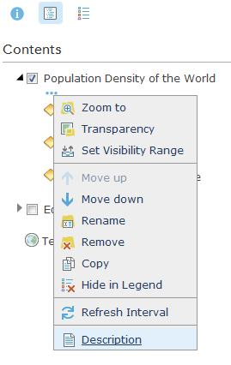
- Who created this data, and what sources did they use?
Use Bookmarks and select India-Nepal. Toggle between population density and the imagery base map. Try making the population density layer transparent by clicking on the small right arrow next to the layer name.
- What is one reason you can think of for the difference between the population density in northern India compared to that of Nepal?
- Use the Measure tool and determine the distance between the area of highest population density in India to the area of lowest population density in Nepal. Be sure to note the distance units you are using (miles or kilometers).
- Switch from the Legend view to the Contents view and turn on the Ecoregions layer. Turn the Population layer on and off and note the predominant ecoregions in the most densely settled regions of northern India. Also, explore the relationship between population density and major rivers. How do you think the dense settlement here may have an effect on the ecoregions of this area?
- Describe the ecoregion and the population density in the region in which you live using the map. How does the population density compare with your earlier observation where you were asked to reflect upon the population density of your area without the aid of a map?
Geodemographics – Having Fun With Stereotypes
The statistics you are examining about population tell only part of the story about the people in those places, of course. One of the ways to measure different aspects of demography is through the creation of a variable that captures a “lifestyle” by neighborhood. It is this variable that marketing folks often use to send you forty catalogs of gourmet food products and coupons for discounted hair transplant surgery (wait - you mean that’s just me?). Marketing folks use this stuff to help determine what is stocked on your local stores’ shelves, what types of cars or bicycles or breakfast sandwiches are sold in your area, what sorts of movies are shown, and a whole lot more.
Go to Bookmarks and select the North America bookmark. Turn off all map layers except the basemap. Then use the Add button to search for and add the 2021 USA Tapestry Segmentation - Stream to your map. Make sure you are searching in ArcGIS Online (the top of the add/search pane), NOT the Living Atlas. Zoom out a couple levels and watch what happens to your map (you should see counties turn into states as you zoom out to show the entire world).
Click your home state (or, if you are from outside the USA, pick any state). You’ll see a popup box reporting the predominant “tapestry segment” for your state. The tapestry segment is one of these lifestyle variables we have been discussing. For Washington state, you should see something like this:
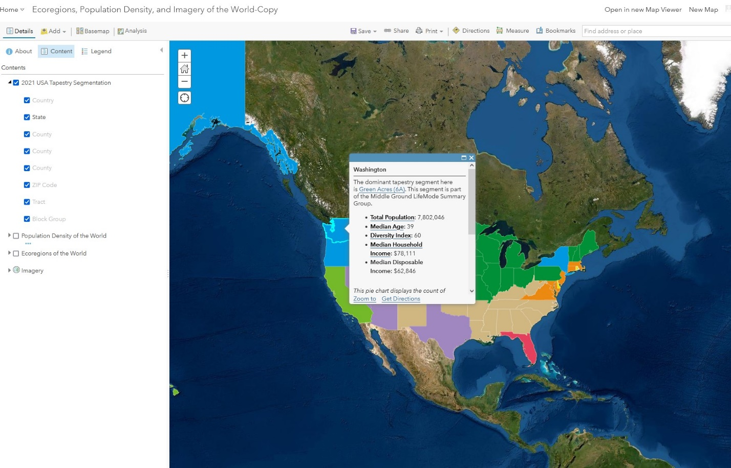
Click the hyperlink in the popup box and read through the descriptions of the Green Acres (etc) tapestry segment profile. These LifeMode profiles help you understand how the different tapestry segments are derived from census, survey, and consumer purchasing data.
Each state contains a lot of different kinds of people, of course, so zoom into your county of interest and note the tapestry segments at this level. As you continue to zoom, you get to zip codes, census tracts, and census block groups. Check out a few of these, especially over near Seattle where they are much smaller. Scale matters!
Now change the Basemap in the neighborhood you are examining to Imagery and then make the Tapestry layer semi-transparent (click on the three dots below “2021 USA Tapestry Segmentation”, then Transparency in order to do this). Set the transparency at about 50%
Is there anything on the imagery that gives a clue as to the neighborhood’s lifestyle? What do the structures and streets tell you about this place?
Feel free to explore additional data layers inside ArcGIS Online. We’ll be using it throughout this course, so if you can become more familiar with it now, it will serve you well later. Add other population data of interest to you, such as median income, median age, and median home value. Do these variables help explain the tapestry segment of your chosen neighborhood and surrounding ones?
Congratulations – You Just Made Some Maps
Awesome job. You have just been using maps in exciting ways to explore the relationships between the environment and people and to examine components of the population, using a web mapping system. Along the way, you have considered scale, data, and other geographic concerns.
Required deliverables for this lab
Using the skills you learned above, add the Tapestry layer to an ArcGIS Online map and zoom into your home neighborhood where you grew up, or some other neighborhood that you know very well. It could be in Ellensburg if you want.
After zooming in as far as the layer allows, click your neighborhood and click the name of the tapestry segment in the popup balloon that appears. You should be taken to a "Tapestry Segmentation" document that follows the format below, although the content will vary based on what type of neighborhood you clicked:
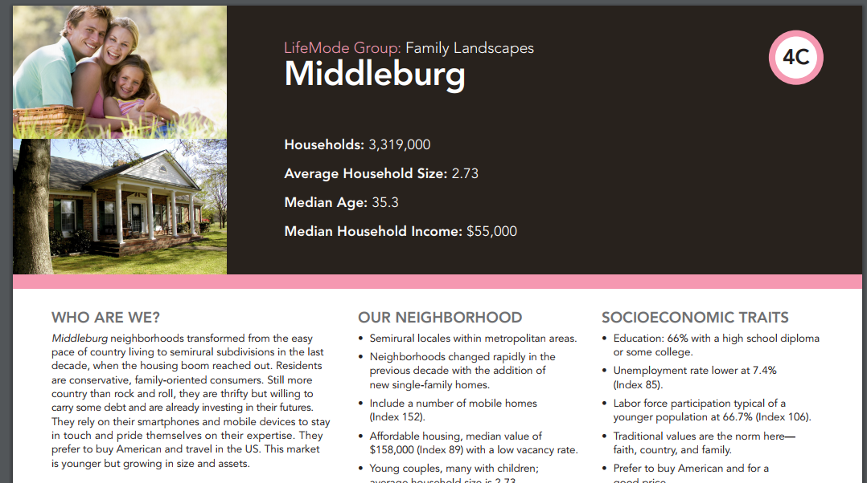
Read this document, especially the section titled Market Profile.
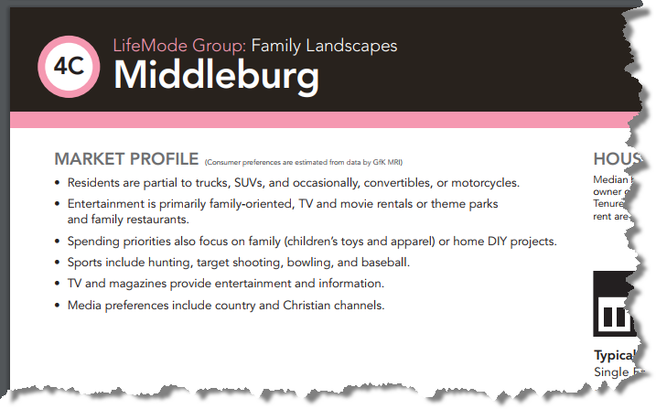

Also, look at the Segment Density map and save a screen capture of it (press Alt + Prnt Scrn and then paste it in Word by clicking Ctrl + V):
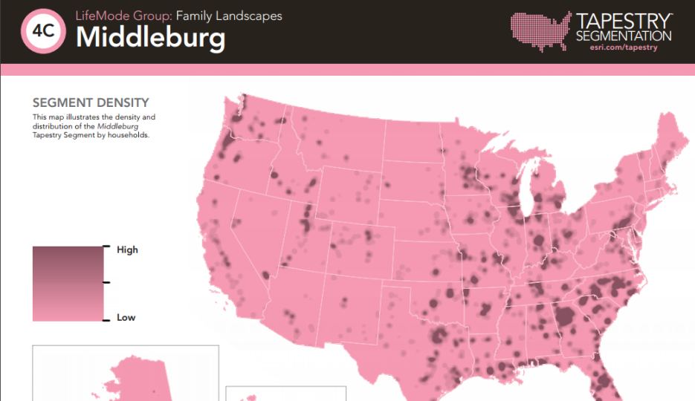
Think about how this information corresponds to your own local knowledge about the neighborhood. Then do the following.
Make a single Word document or PDF with the following things in it, print it out, and turn it in to the thingy on my office door (234 Dean Hall):
- Address these questions in a thoughtful paragraph: What kinds of spatial and non-spatial data need to be obtained in order to make the kinds of conclusions that were made in this "Tapestry Segmentation" document? What are some specific sources of data that you think Esri used in order to draw these conclusions?
- Address these questions in a thoughtful paragraph: In what ways does the "Market Profile" section of the "Tapestry Segmentation" accurately describe the neighborhood you clicked, and in what ways is it inaccurate? In what ways could these types of generalizations about a place be useful and in what ways might they be problematic?
- Insert a screen capture of the map with your neighborhood clicked and a screen capture of the Segment Density Map, as shown below. Describe what places in the United States are similar to your neighborhood’s tapestry segmentation. Does this surprise you, or not? Why?:
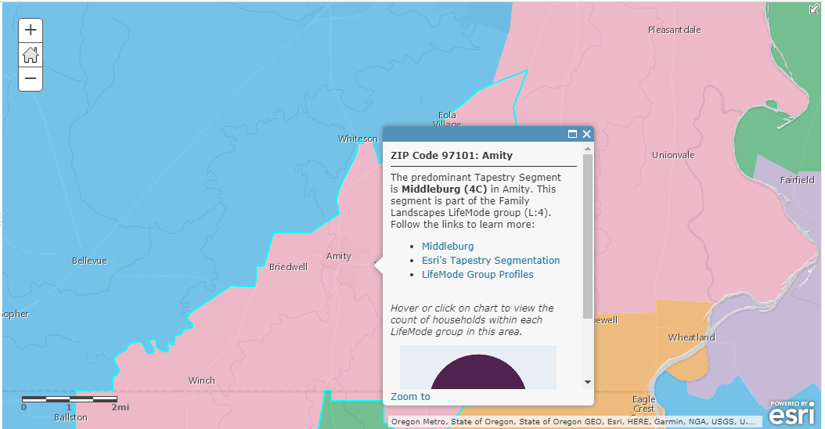

For example, the neighborhood near Amity, Oregon, that I clicked, is similar to a lot of northwestern Georgia. This seems hard to explain, at first, since the two are so far apart geographically, but both have a rural, conservative character that matches elements of the “Middleburg” segment.
Need Help?
Contact me.

