(revised, October, 2022)
OK. Fire up Google Earth Pro (GE)
Note, if you’re at home and haven’t installed GE-pro, just google “download google earth”, get it, install. Make sure you grab the pro version – it has way more capability. If you’re running chrome or win 11, be sure to specify that in your google search. Also, parts of this lab are based roughly on one created at Southwestern College in Chula Vista, CA (couldn’t find an author).
From here, let’s get a handle on some of the basic features of GE. There are a few questions scattered throughout. Answer them as you get there. Those answers will be what you turn in! Note, all I want to see in what you turn in are the questions and your answers – delete all the other stuff when finished. It will make it a lot easier for me to grade. And you will get a better grade.
GE is a friendly, 3D, internet-based geographic mapping application. It was originally developed by Keyhole Inc., located in Silicon Valley. In 2004, Google bought Keyhole and released Google Earth in 2005. The generic term for this is a Digital Earth (or Globe). There are a couple of other similar applications out there, but none are as good or popular.
A bit of the basics:
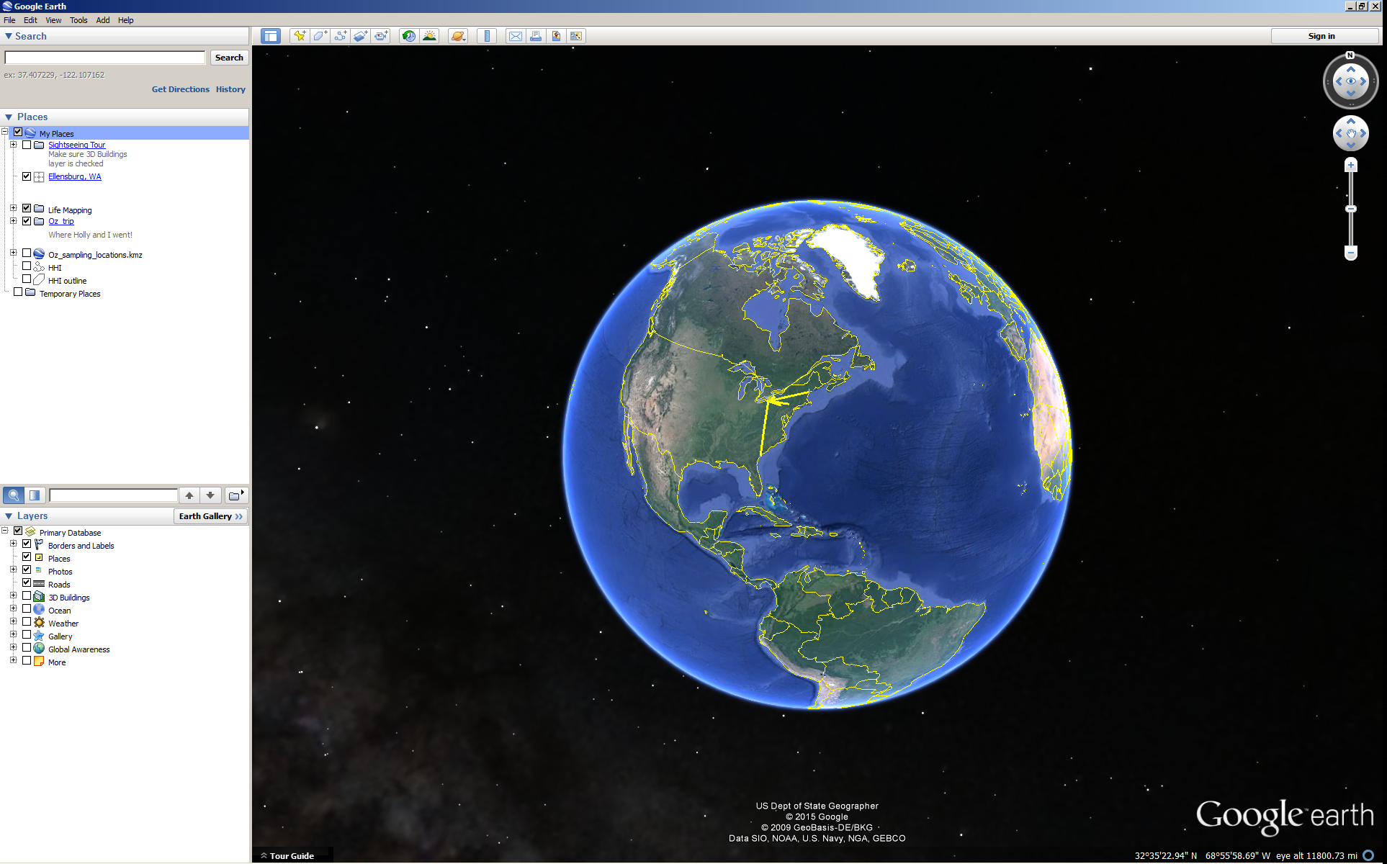
There are three operational panels to the left of the screen, navigational controls to the right, and the map view in the middle.
The “look” control (upper right) controls the direction of view. You can also change the angle of view. Mess around and become familiar.
The “move” control is right below the look. It allows you to change your position. It works the same as clicking on the map and dragging.
The “pan/zoom slider” is below that. Yup. You can pan and zoom. You can also pan/zoom with the scroll wheel on your mouse.
To the left, you can search in the search panel.
Places is where you control adding and subtracting files, whether created by you or downloaded from the interwebz somewhere. We’ll do a bit of this later.
Finally, in the bottom left are the layers you can turn on and off. Mess around – there’s a freaking ton of cool stuff here.
Up top are a series of buttons. Some we’ll get to, others not. But it’s worth checking out. More on some later as we go through a series of questions. You will hand in the answers to the italicized questions.
Stuff to do:
1. Fly to Ellensburg by typing “Ellensburg, WA” into the search box and hitting enter (or the search button). Welcome to paradise.
2. From the layers section, be sure that borders and labels, places, photos, and 3D buildings are turned on. Just for giggles. Check out some of the photos. A number are from moi (or students). Bonus to anyone finding the epic photo of two great horned owls taken on campus.
3. OK. In the olden days (a couple of years ago), the only 3D building on GE were ones drafted by individuals and posted up to GE. These days, Google has some sort of automated algorithm which automatically generates everything in 3D. Very cool, I’ll note that the GE view defaults to the 3D data, even if there is more recent imagery available. In areas without 3D data, the default is the most recent data. but no longer is the work my students did in Ellensburg visible. Make sure 3D buildings are on. Now, answer the following

- Question 1a: What is the date the 3D imagery was taken? Note, this may take some work to figure out. In fact, you just might want to do the rest of question 1 and come back to this.
- Question 1b – what is the approximate extent of 3D imagery in the Ellensburg area. Yup, you’ll need to zoom in/out, move around, etc. Your answer will be in miles E/W by miles N/S.
The older building that predate the automatic imagery are still available on GE. To view it, click on the little clock (top or bottom of the page) – you will see a slider in which you can see both older and newer imagery. Check out how Ellensburg/campus has changed. Be sure that 3D buildings is checked. Now, you can look at what my students have done. Note, to answer the below 4 questions, you will need to be in the historical imagery view.
- Question 2a) What is the oldest imagery available over campus?
- Question 2b) What is the most recent imagery imagery available over campus?
- Question 2c) how many buildings on campus are in 3D?
- Question 2d) How many buildings on the rodeo grounds are in 3D?
Muck around a bit more and see what you can see in 3D. It’s cool.
Now, time to explore part of the world in 3D.
1. Fly to the Grand Canyon by entering Grand Canyon in the search box. Play with the look and zoom so that you can literally see in 3D and pan/zoom down the canyon.
2. Now for the fun part. And you may never have a geography prof tell you to play games. Yup, time for the flight simulator. Fire that up by going to Tools – Enter Flight Simulator. I suggest you pick the little prop plane. And read the help. Thoroughly. And perhaps take a few notes. Then fire it up and fly. Prepare to crash. But with a little patience, YOU can FLY! And if you can’t and want some pro assistance, go see Dr. Bowen – he’s amazing with flight simulator.
3. Now, do the same for Seattle. Make sure 3D buildings are turned on. Buzz the Space Needle and EMP. Just for fun.
- Question 3 – write down your opinions regarding both what you can see in GE and the flight simulator. This should be a good half a page.
Remember projections, datums, and coordinate systems? As you might think, they’re pretty dang important (not really the projection, as you’re looking at a pseudo 3d system, but the others have to be spot on, or none of this cool data would overlay properly. So, you ask, where is all this exciting information? The answer is to goto tools – Options. Go there. Check it out. There are all kinds of preferences you can set.
- Question 4 – which coordinate systems are available for you to use?
Now, it’s time to get down and personal. Zoom to your house by typing the full address into the search bar. Because you want to be able to get here quickly in the future, add a placemark (the pushpin button at the top). Move it to the right spot (on top of your house) and give it a name. You will see it appear in your “Places” part of the screen (middle left).
- To prove you did this, take a screenshot and paste it into your word/answers document: Question 5).
At the moment, this placemark is temporary and will go away when you quit GE. However, you will have the option to save placemarks when you exit GE, but don’t if you’re in the lab.
Distance time.
- Question 6: Using the “show ruler” button (it looks like a ruler), tell me the straight line distance between your house and Dean Hall. In miles. And kilometers.
Let’s add directions to this distance. Head back up to the search area. You will see “get directions.” Click on it. Type in your home address and “Dean Hall, CWU, Ellensburg, WA” Hit enter.
- Question 7: what is the road distance from your home to Dean Hall. In miles.
Just for fun. And because data is born free. Check out both Area 51 and Camp David (two different places). The coordinates of A51 (copy/paste into search) are 37.249361, -115.812339. A search on “camp david” will get you to the presidential retreat.
- Question 8: What does Area 51 look like to you (shopping mall, lake, etc)? Almost all the lush vegetation is a ____________ ?
Note, this is the old school 3D. Someone drafted a bunch of buildings and uploaded them. They aren’t GE’s new 3D everywhere stuff.
- Question 9a. How many buildings at Camp David have been done in 3D?
- Question 9b. Camp David is mostly covered by (asphalt, fields, grass, dense trees, sparse trees?)
- Question 9c. Camp David is located in the State of (Maryland, Virginia, PA, Delaware, West Virginia)?

But… even more important… where’s the nearest pizza joint to your house????? Type “pizza Ellesburg” (or whatever town you happen to live in). You will see a bunch pop up.
- Question 10: how accurate is this search? Did they get the closest one to you? Anything missing?
Go back to the Grand Canyon by searching on that name.
- Question 11a) using your distance tool (the ruler at the top of the page), how many bridges are there between 20 miles upstream and 20 miles downstream of the Grand Canyon pin (red A that you initially zoomed to)? If there are, what kind of bridge are they?
- Question 11b) If you were at the South Rim (where S Entrance Road meets Desert View Drive), how far would you have to travel to the nearest road bridge over the Colorado River (NOT the Little Colorado River) – a place you could cross in a car? Give both linear distance and Road distance (use different options within the distance tool).
Because the Earth is boring. Let’s goto Mars! Goto View – Explore – Mars. Check it out. Now, search for Curiosity Rover – check out where it was, some pics, etc. Just because it’s freaking cool.
- Question 12: What was the most interesting thing you saw on Mars? Describe it in at least three sentences, say why you thought it was cool, and give the lat/long coordinates for it.

Note, if you thought Mars was kinda cool, you can see the whole solar system in detail, goto maps.google.com . You then need to make sure you’re in satellite and globe view (mouse over the layers icon in the bottom left corner, click on “more”, then make sure you’re in sat/globe mode. Then scroll out until the solar system pops up on the left side. Go into the planets from there! So cool. Check it out. (note, this works in both chrome and firefox, haven’t tested it on other browsers)
Back to Earth...
- The content displayed in Google Earth has changed over the years. These days, they are focused on keeping their imagery current, doing street view stuff, and adding historical imagery. Contributions from individuals and cool projects from outside google are out.

For fun, goto Mount Rushmore National Memorial. Check it out in 3D.

13) What is the tunnel behind the heads? (yes, google is your friend)

Google Maps
Let’s now switch over to the similar Google Maps. Goto maps.google.com in your browser. This software is much like Google earth, though it is better for things like routes and finding businesses. GE is much better at looking at landscapes. Maps does not have historical imagery.

However, Maps does have a feature that is extra cool. Click on the layers button in the lower left corner. Then select more. Then click satellite and globe view. Now, back to the map and zoom out. At some point, a menu pops up on the left side, and you can look at all the planets and many of the moons in our solar system. Surf around a little. Check out Pluto (which is a planet, dang it!). And then realize that this is the best image ever taken of Pluto from Earth: https://www.space.com/17784-best-pluto-photo-from-earth-picture.html The Hubble orbital space telescope did better. But the New Horizons probe got the images you see: https://www.planetary.org/space-images/pluto-new-horizons-vs-hubble

Ain’t Technology amazing?

