Moisture, Precipitation, and Clouds: Why does it rain and where?

Lab originally created by Dr. Carsten Braun: http://www.westfield.ma.edu/academics/geography-and-regional-planning-department/dr.-carsten-braun . Modified by Bob Hickey

Lab Objectives – to better understand the relationships between moisture and temperature. And thus, why/where it rains!

As usual, work through this lab then do the online quiz. There’s some basic arithmetic – be sure you have a calculator.

Part 1) Introduction.

How can we quantify the amount of water vapor in the air?
Mixing Ratio. The mixing ratio describes the actual amount of water vapor in the air and is expressed as the mass (= the weight) of the water vapor in a given mass of dry air (grams of water per kilogram of air). We called this Absolute Humidity in lecture.
Relative Humidity. Relative humidity does not describe the actual amount of water vapor in the air. Instead, it compares the actual amount of water vapor in the air (= the mixing ratio) to the maximum amount of water vapor that the air can hold at a given temperature. Thus, the relative humidity (RH) expresses the degree of saturation as a percentage.

Relative Humidity = Actual Water Vapor Content / Water Vapor Capacity

Example.
50% RH means that the air contains half of the water vapor necessary for saturation.
75% RH means that the air contains three-quarters of the water vapor necessary for saturation.
100% RH means that the air is saturated.

Once the air is saturated, condensation occurs and clouds form.

Saturation Mixing Ratio. The water vapor capacity of air at a given temperature is also called the saturation mixing ratio (we called it saturation humidity in lecture), since it is the mixing ratio of a saturated parcel of air. The water vapor capacity of air depends on its temperature (Table 1 – at the end of this entire document). As temperature increases, the water vapor capacity or saturation mixing ratio also increases.
In popular terms: Warm air can ‘hold’ more water vapor than cold air.
Calculating Relative Humidity. In this exercise you will use the mixing ratio (absolute humidity) to describe the actual water vapor content of the air and the saturation mixing ratio to describe the water vapor capacity of the air. Relative humidity is then calculated using a simple equation:
Relative Humidity = (Mixing Ratio / Saturation Mixing Ratio) * 100

For example, if the mixing ratio is 13.5 g/kg and the saturation mixing ratio is 22.5 g/kg, the relative humidity of the air is 60%. Relative Humidity = 13.5 g/kg / 22.5 g/kg * 100 = 60%

The key is to understand that air temperature and saturation mixing ratio are linked – warmer air has a much greater ability to hold water vapor – therefore, when air temperature changes, relative humidity changes.
As air temperature decreases, saturation mixing ratio decreases and RH increases.
As air temperature increases, saturation mixing ratio increases and RH decreases.
If the air is cooled enough, its mixing ratio will match its saturation mixing ratio and the air will be saturated (RH = 100%). If cooling continues…the relative humidity will remain at 100% and more and more water vapor will condense out of the air (which translates to clouds and precipitation)
The Dew Point Temperature. The temperature at which the air reaches 100% relative humidity is called the dew point temperature. This is the temperature at which the saturation mixing ratio is equal to the mixing ratio (absolute humidity = saturation humidity).
The dew point temperature is always determined by the mixing ratio – for example, the dew point for air with a mixing ratio of 11.1 g/kg is always 60°F (Table 1 – end of the document).
- If you know the temperature, you can determine the saturation mixing ratio = the maximum amount of water vapor that the air can hold.
- If you know the mixing ratio, you can determine the dew point of the air by finding the value of the mixing ratio in the ‘saturation mixing ratio’ column – the dew point is the corresponding temperature. Remember: At the dew point temperature the air is saturated, so the mixing ratio and the saturation mixing ratio are the same.
- If you know the dew point, you can determine the mixing ration of the air by finding the value of the dew point in the temperature column – the mixing ratio is the same as the saturation mixing ratio (again, at the dew point, RH is 100% and the mixing ratio and the saturation mixing ratio are the same).

Part 2: Temperature and Moisture Content of Air.
Question 1. Complete the following table (round off relative humidity to the nearest percent). You will need to spend quality time with Table one and the equations you learned above.
Mixing Ratio (g/kg) | Air Temperature (°F) | Saturation Mixing Ratio (g/kg) | Relative Humidity (%)
2.8 | 30
2.8 | 90
11.1 |  | 13.2
22.3 |  | 36.5

Question 2. You are sitting in your dorm room with an air temperature of 65°F and a mixing ratio of 5.2 g/kg.
(a) What is the relative humidity? _______________________
(b) What is the dew point? _______________________
(c) You are cold and turn-up the heat…and heat the room to 80°F.
What is the new relative humidity of your room? _______________________
Question 3. You are studying in your dorm room with an air temperature of 70°F and a mixing ratio of 7.6 g/kg.
(a) What is the relative humidity? _______________________
(b) What is the dew point? _______________________
(c) You open the window…and the room temperature drops by 10°F per hour.
How many hours will it take for the air in your
room to reach saturation? _______________________
(d) You leave the window open for 1 more hour.
How many grams of water vapor will condense out of the air to maintain a relative humidity of 100%? _______________________
Question 4. Imagine an ugly summer day in Seattle. It’s hot (90°F) and muggy (the air is saturated with water vapor.
(a) What is the relative humidity? _______________________
(b) What is the dew point? _______________________
c) Your air conditioner brings this air into your house and cools the air down to 70°F.
How many grams of water will condense out of the air? ____________________

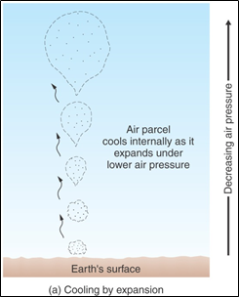
Part 3: Atmospheric Lifting.

We know that relative humidity increases as air temperature decreases. Once an air parcel has cooled to its dew point temperature it becomes saturated and condensation occurs.
The common way in the atmosphere that air is cooled is by adiabatic lifting.
As a parcel of air rises in the atmosphere it reaches lower pressure and therefore expands. When air expands, it cools – that’s a fact of physics. Conversely, when air sinks it reaches areas of higher pressure, becomes compressed and therefore warms. Again, that’s a fact of physics. And you never win when you argue with physics.
Rising of Unsaturated Air. As long as the rising air in not saturated it will cool about 5.5°F for every 1,000 feet it rises. This cooling rate is called the Dry Adiabatic Lapse Rate or DALR.
As the air rises and cools, its relative humidity increases. At some point, the air has cooled enough to reach its dew point temperature, meaning that the air is now saturated and the RH is 100 percent. This elevation in the atmosphere is called the Lifting Condensation Level or LCL.
Rising of Saturated Air. Now the saturated air continues to rise and it will continue to cool, but at a slower rate. Saturated air cools at about 3.3°F for every 1,000 feet it rises. This cooling rate is called the Wet Adiabatic Lapse Rate or WALR.
Why is the DALR greater than the WALR? Well – what that means is that saturated air cools more slowly than unsaturated air because of the release of latent heat during condensation. When water condenses back to liquid from vapor heat is released – the same energy it took to convert the water from liquid to vapor in the first place.
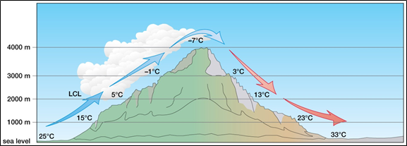
The figure above (Source: McKnight and Hess, Physical Geography, 9th ed.) shows the temperature changes of an air parcel as it rises up and over a mountain chain. In this hypothetical example, the dew point temperature of 5°C is reached at 2,000 m (= the LCL).
Note that the air descending down the right side of the mountain chain warms all the way at the DALR. This is because the air lost all of its moisture on the rise (= left windward side) and is now dry and unsaturated – thus warms at the DALR. Therefore, the air ends up 8°C warmer compared to when it started!
The figure below shows the same situation for an air parcel rising in the atmosphere:

Note, DAR=DALR and SAR (saturated lapse rate)=WALR
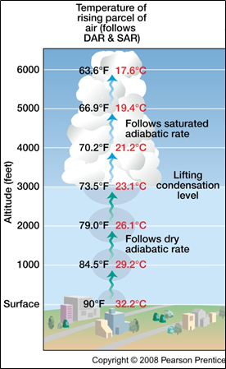
- The unsaturated air cools at the DALR as the parcel rises, expands, and therefore cools.
Due to the cooling the RH increases.
- Once the air has cooled enough – specifically to its dew point temperature – the RH will reach 100 percent. This occurs at the LCL which is visible to us as the base of the clouds.
- The air parcel continues to rise inside the cloud, but now it is saturated.
- Therefore, any further cooling is accompanied by condensation (hence we see a cloud). Condensation releases latent heat, thus the cooling rate is now slower (= WALR) as the air cools itself by expansion but also warms itself at the same time due to condensation and latent heat release.

Below, assume that the air is forced to rise from left to right across this 6,000-foot high mountain chain. The initial air temperature is 76.5°F at sea level and the LCL is at 3,000 feet. The DALR is 5.5°F per 1,000 feet; the WALR is 3.3°F per 1,000 feet. Assume that condensation starts at 100 percent RH and that no evaporation takes place as the air descends down the rain-shadow side of the mountain chain.
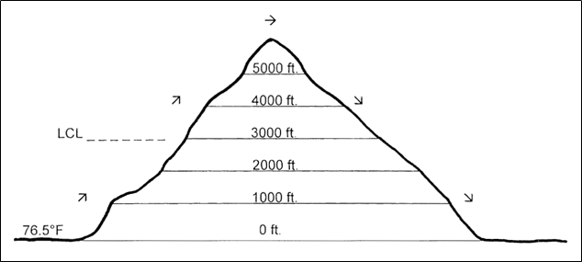

Question 5. Calculate the temperature of the air parcel at the following five elevations as it rises up and across the mountain chain.
(a) At 1,000 feet __________________________
(b) At 3,000 feet __________________________
(c) At 6,000 feet __________________________
(d) At 3,000 feet (east side) __________________________
(e) At 0 feet (east side) __________________________
Side note – this is exactly what you see on islands! Think Hawaii

Question 6. The air parcel is now warmer than it was when it started at sea level on the windward side of the mountain? Explain the source of the heat energy.
Question 7. On the windward side of the mountain: Is the relative humidity increasing or decreasing as the air rises from sea level to 3,000 feet?
Question 8: On the windward side of the mountain, the RH is ___________ as the air rises from 3000’ to 6000’.
Question 9. On the rain-shadow side of the mountain: Is the relative humidity increasing or decreasing as the air descends from 6,000 feet to sea level?
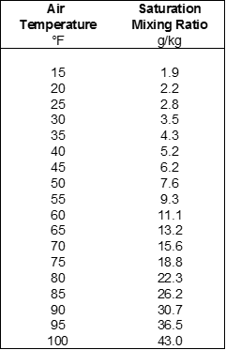

Table 1. Saturation mixing ratio in g/kg at various air temperatures. The saturation mixing ratio describes the maximum amount of water vapor the air can hold at complete saturation. The below chart is from the Table 1 data

